Exp no: 4

PROTOTYPES -FAMILIAR AND UNFAMILIAR :

What is familiar prototype?

**Familiar Prototype**:

* Based on existing mental models and common design patterns.
* Example: A shopping cart icon for online purchases.
* **Benefit**: Easier for users to understand and navigate, reducing the learning curve.

What is unfamiliar prototype?

**Unfamiliar Prototype**:

* Introduces new or innovative design concepts.
* Example: A gesture-based interface for navigation instead of traditional menus.
* **Benefit**: Allows for creativity and unique experiences but may require more guidance and user adaptation.

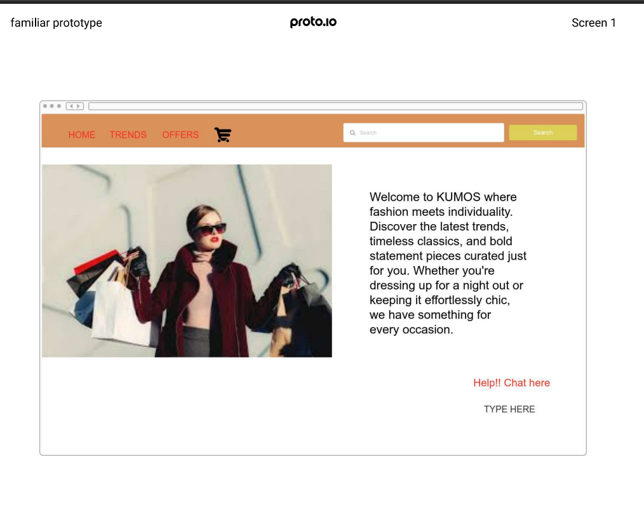

Unfamilar:



